**EPWMD MIGRATOR TOOL**

**About the Tool**

* This tool uploads data from Excel Database declared in the config file to Solr core qc_biz, and Cassandra Tables qc_biz, ec_compliance, epwmd_mission_orders and epwmd_violations.
* The Document fields that are uploaded to solr contains the following fields:

1. establishment_id - system generated UUID
2. bpn - Business permit number/MP number
3. trade_name - company name
4. risk_level
5. business_nature
6. loc_street - street address
7. loc_brgy - barangay address
8. loc_district - district address
9. emails - email address/contact
10. waterway
11. geocode - longitude|latitude
12. tel_nos - telephone number
13. occupancy_type - stand alone/Line
14. line_occupant
15. total_employees
16. lot_area_sqm
17. work_sched_time
18. work_sched_days

* The Document fields that are uploaded to cassandra table qc_biz contains the following fields:

1. establishment_id - system generated UUID
2. bpn - Business permit number/MP number
3. trade_name - company name
4. risk_level
5. business_nature
6. loc_street - street address
7. loc_brgy - barangay address
8. loc_district - district address
9. emails - email address/contact
10. waterway
11. geocode - longitude|latitude
12. tel_nos - telephone number
13. occupancy_type - stand alone/Line
14. line_occupant
15. total_employees
16. lot_area_sqm
17. work_sched_time
18. work_sched_days
19. date_created - configurable
20. created_by - configurable

* The Document fields that are uploaded to cassandra table ec_compliance contains the following fields:

1. establishment_id - system generated UUID
2. clearance_type- New/Renewal
3. date_applied - Date of Issuance
4. ctrl_no - Control number
5. bpn - Business permit number/MP number
6. risk_level
7. business_nature
8. submitted_docs_validity - Map<document, validity date>
9. submitted_docs_issued - Map<document, date issued>
10. mission_order_no
11. payment_date
12. amt_paid - Map<fee, amount>
13. or_no = official receipt number
14. date_created - configurable
15. created_by - configurable

* The Document fields that are uploaded to cassandra table epwmd_mission_orders contains the following fields:

1. establishment_id - system generated UUID
2. bpn - Business permit number/MP number
3. inspection_date
4. mission_order_no
5. case_officer
6. date_created - configurable
7. created_by - configurable

* The Document fields that are uploaded to cassandra table epwmd_violations contains the following fields:

1. establishment_id - system generated UUID
2. bpn - Business permit number/MP number
3. violation_id
4. date_issued
5. offence_nature
6. Officer
7. payment_date
8. total_amt_paid
9. or_no - official receipt number
10. date_created - configurable
11. created_by - configurable

* The Document fields that are uploaded to cassandra table epwmd_solid_waste contains the following fields:

1. establishment_id - system generated UUID
2. date_applied - Date of Issuance
3. mission_order_no
4. inspection_date = Date of inspection
5. daily_waste_generation = Map<waste type, daily generation>
6. hauler_collection_frequency = Map<hauler, collection frequency>
7. date_created - configurable
8. created_by - configurable

* The Document fields that are uploaded to cassandra table epwmd_hazardous_waste contains the following fields:

1. establishment_id - system generated UUID
2. date_applied - Date of Issuance
3. mission_order_no
4. inspection_date = Date of inspection
5. daily_waste_generation = Map<waste type, daily generation>
6. hauler_collection_frequency = Map<hauler, collection frequency>
7. date_created - configurable
8. created_by - configurable

* The Document fields that are uploaded to cassandra table epwmd_structural_requirements contains the following fields:

1. establishment_id - system generated UUID
2. date_applied - Date of Issuance
3. mission_order_no
4. inspection_date = Date of inspection
5. septic_tank
6. stp_wwtf
7. sewerage_connection
8. grease_trap
9. grease_interceptor
10. oil_water_separator
11. materials_recovery
12. emission_source
13. painting_booth
14. sound_proofing
15. date_created - configurable
16. created_by - configurable

**Tool Requirements**

·         The users must be given a read access to the input path and write access rights to the log path defined in **config.properties** file.

·         Java Development Kit 8 (JDK 8) must be installed in the machine.

**Tool Configuration File Settings (config.properties)**

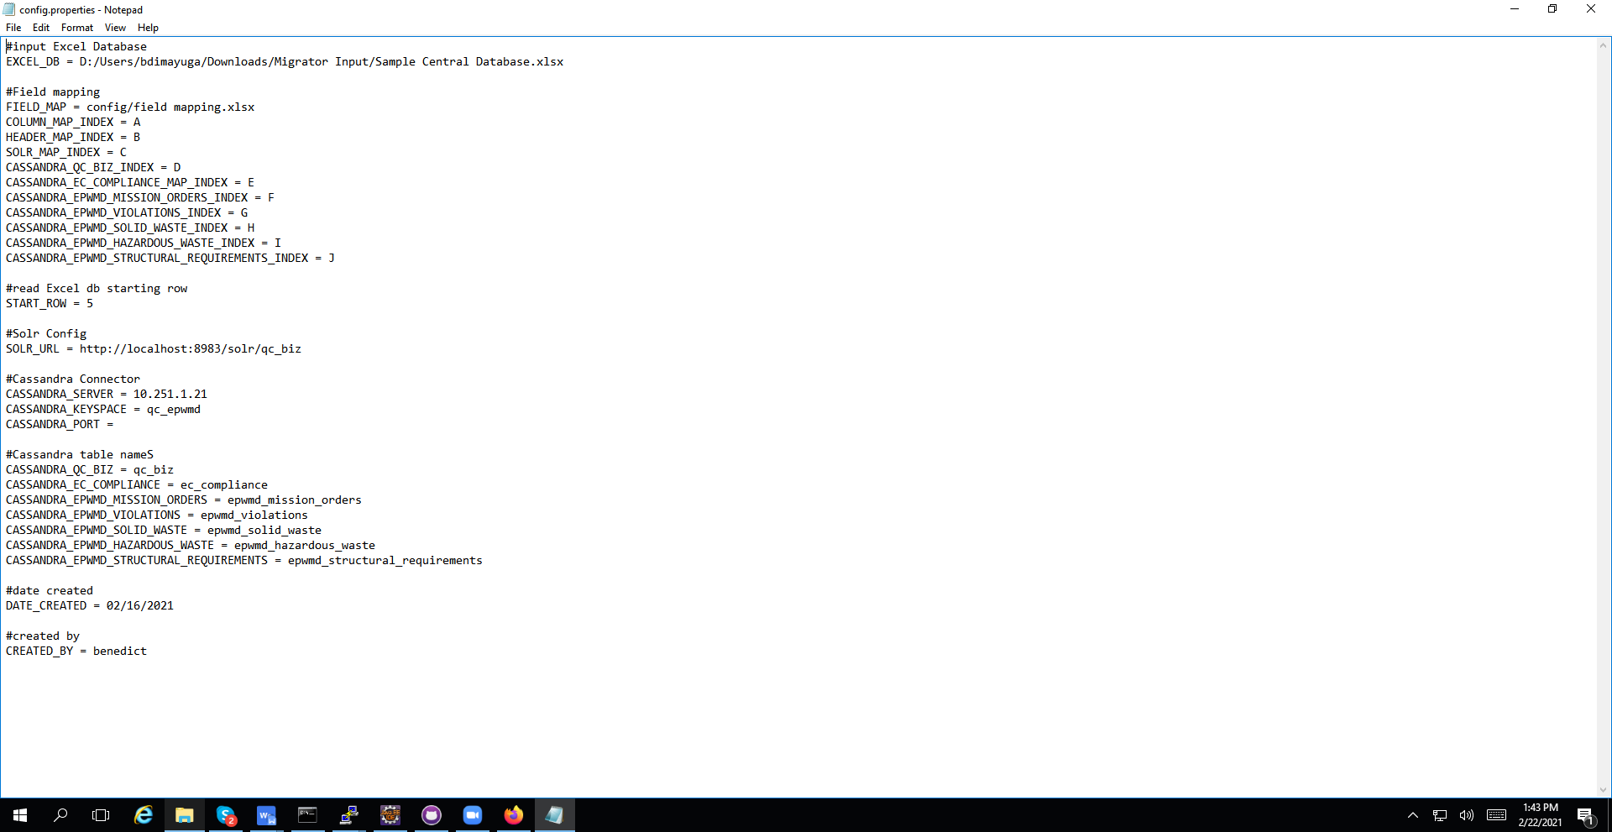

EXCEL_DB = input excel file

FIELD_MAP = field mapping excel file

COLUMN_MAP_INDEX = column index of the columns

HEADER_MAP_INDEX = column index of headers

SOLR_MAP_INDEX = column index of solr field mapping

CASSANDRA_QC_BIZ_INDEX = column index of qc_biz cassandra table field mapping

CASSANDRA_EC_COMPLIANCE_MAP_INDEX = column index of ec_compliance cassandra table field mapping CASSANDRA_EPWMD_MISSION_ORDERS_INDEX = column index of epwmd_mission_orders cassandra table field mapping

CASSANDRA_EPWMD_VIOLATIONS_INDEX = column index of epwmd_violations cassandra table field mapping

CASSANDRA_EPWMD_SOLID_WASTE_INDEX = column index of epwmd_solid_waste cassandra table field mapping

CASSANDRA_EPWMD_HARARDOUS_WASTE_INDEX = column index of epwmd_hazardous_waste cassandra table field mapping

CASSANDRA_EPWMD_STRUCTURAL_REQUIREMENTS_INDEX = column index of epwmd_structural_requirements cassandra table field mapping

START_ROW = row of the input excel file to start reading from

SOLR_URL =url of solr

#Cassandra Connector

CASSANDRA_SERVER = ip address of cassandra server

CASSANDRA_KEYSPACE = keyspace to be used

CASSANDRA_PORT = n/a

CASSANDRA_QC_BIZ = qc_biz

CASSANDRA_EC_COMPLIANCE = ec_compliance

CASSANDRA_EPWMD_MISSION_ORDERS = epwmd_mission_orders

CASSANDRA_EPWMD_VIOLATIONS = epwmd_violations

CASSANDRA_EPWMD_SOLID_WASTE= epwmd_solid_waste

CASSANDRA_EPWMD_HAZARDOUS_WASTE= epwmd_hazardous_waste

CASSANDRA_EPWMD_STRUCTURAL_REQUIREMENTS= epwmd_structural_requirements

DATE_CREATED

CREATED_BY

The field mapping.xlsx contains the mapping of data for solr and cassandra upload.

A row consists of column index and header title and may or may not have corresponding fields from solr and cassandra columns.

The field “hauler_collection_frequency” of epwmd_solid_waste is type map<text,text>. The key is equal to the cell value of the “hauler” cell and the value is equal to the next cell’s cell value.

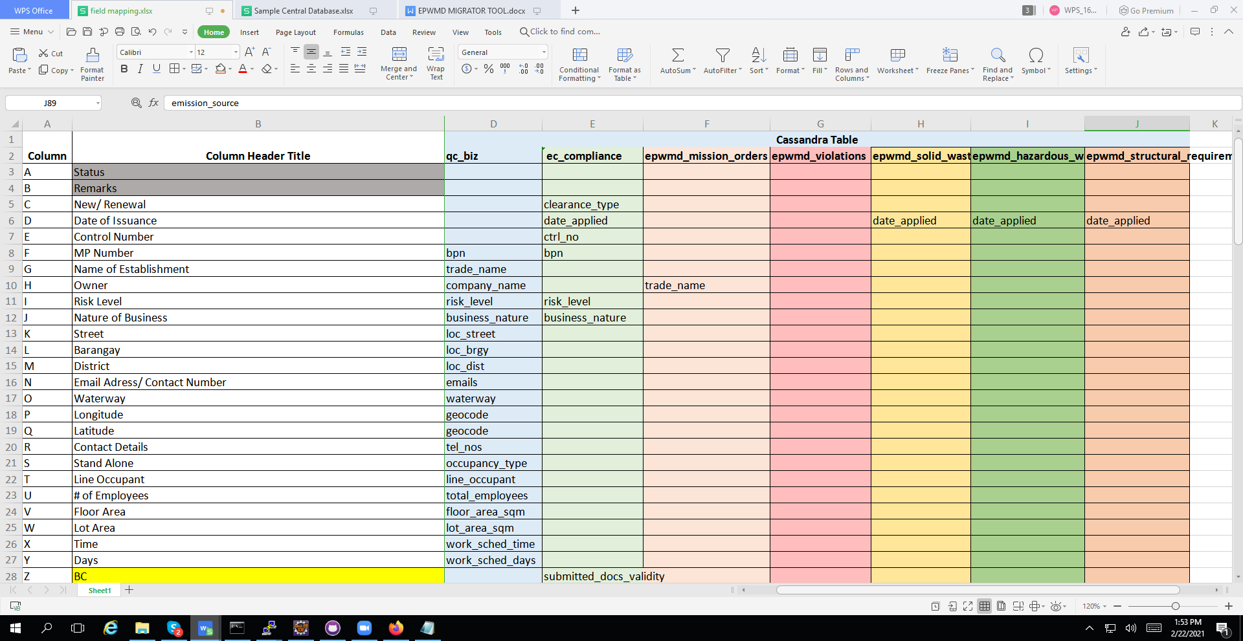

If ever a field is needed to be added, just add a row. Make sure to add value to the column header title and the column where the new field will fetch its value from the excel database. Same goes for deleting a field, just delete the entire row of the field that should be deleted.

**Running the Application**

Deploy solr server: open command prompt,

Type :cd (location of bin folder of currently installed solr)

e.g. cd C:/solr-7.7.3/bin

Type: solr start

Check and update config.properties to desired inputs then save

Chech the input excel file, make sure that all date related columns are of type “long date”

In Command prompt, go to the extracted runnable jar file location

  e.g. cd C:/jars/migrator_tool

Run jar file

Type: java -jar migrator.jar

**Sample Output**

Solr admin:

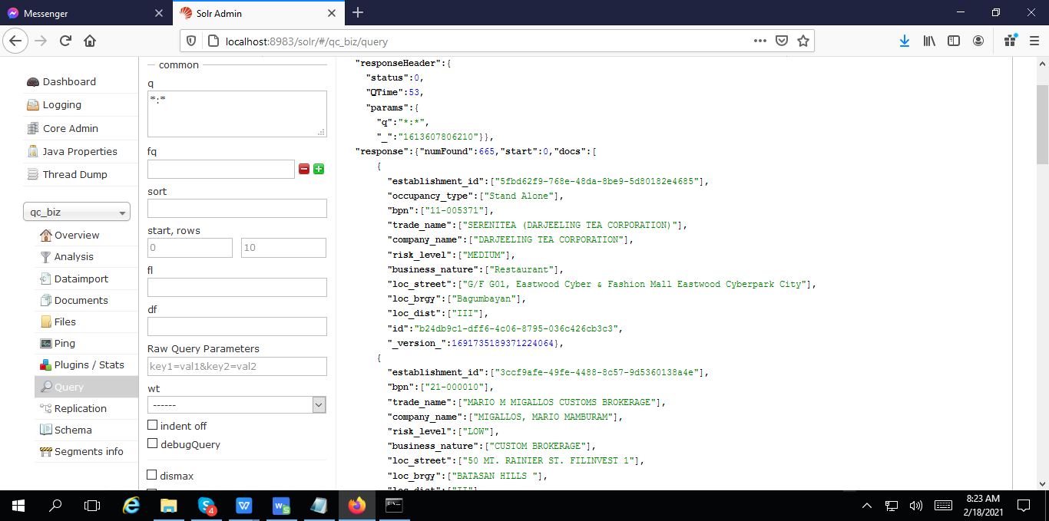

Cassandra table qc_biz:

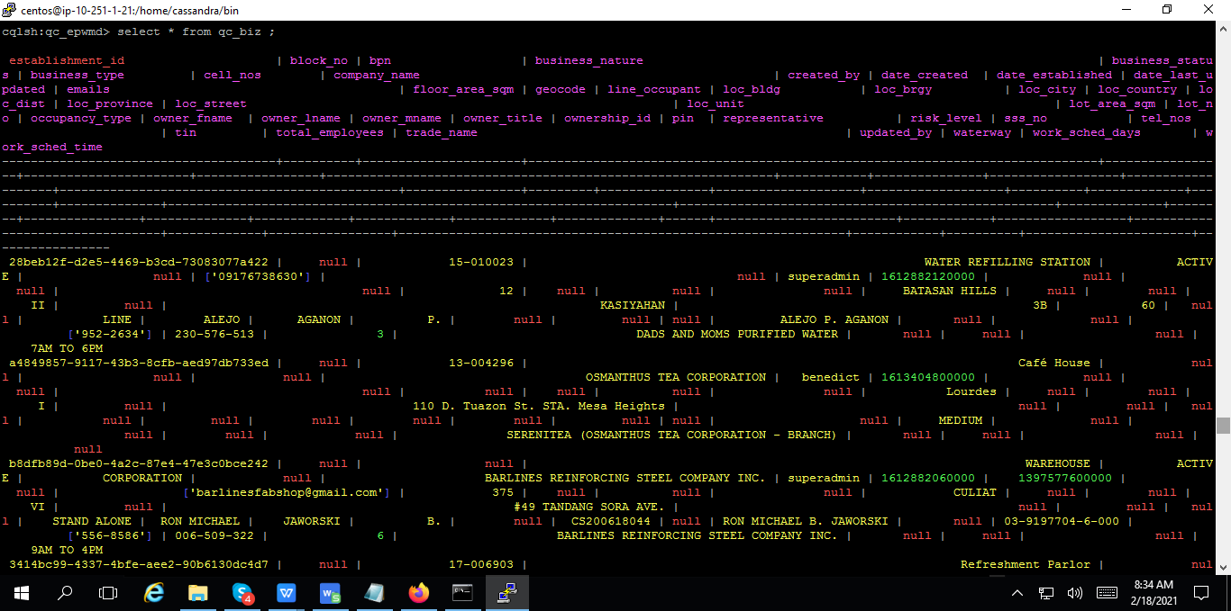

Cassandra table ec_compliance:

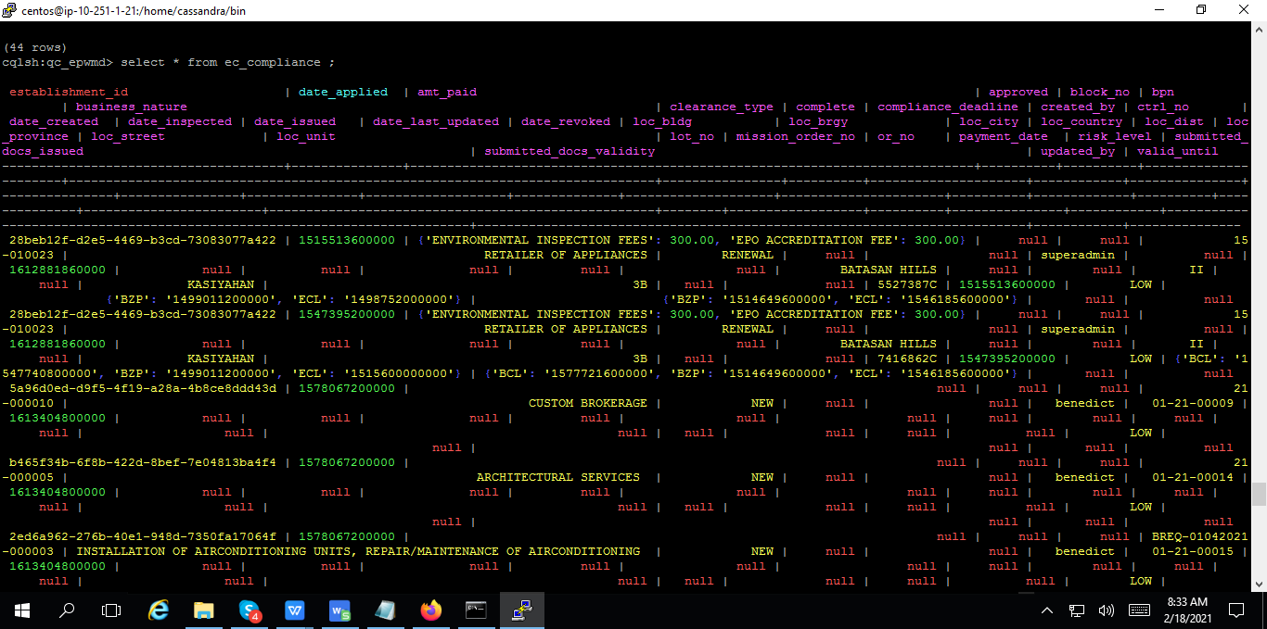

Cassandra table epwmd_mission_orders:

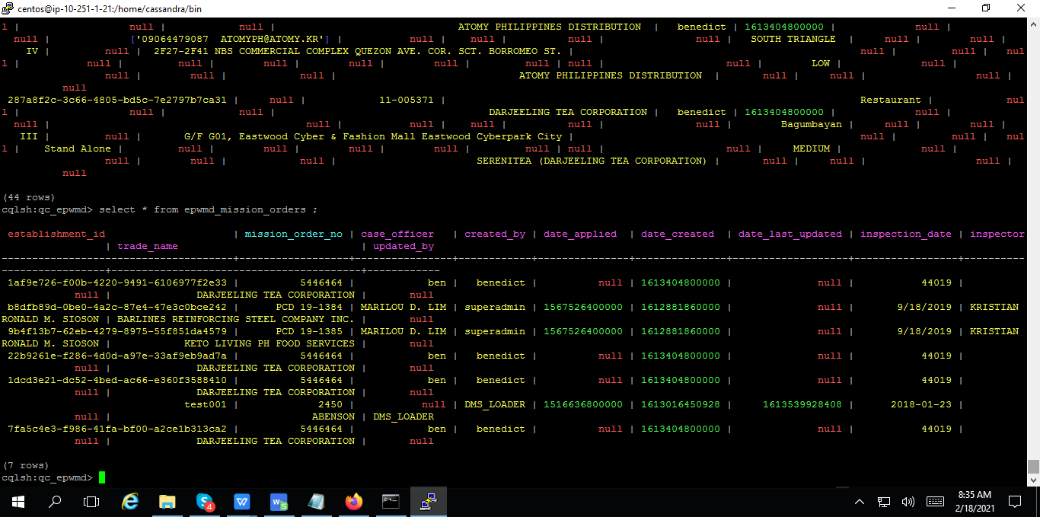

Cassandra table epwmd_violations:

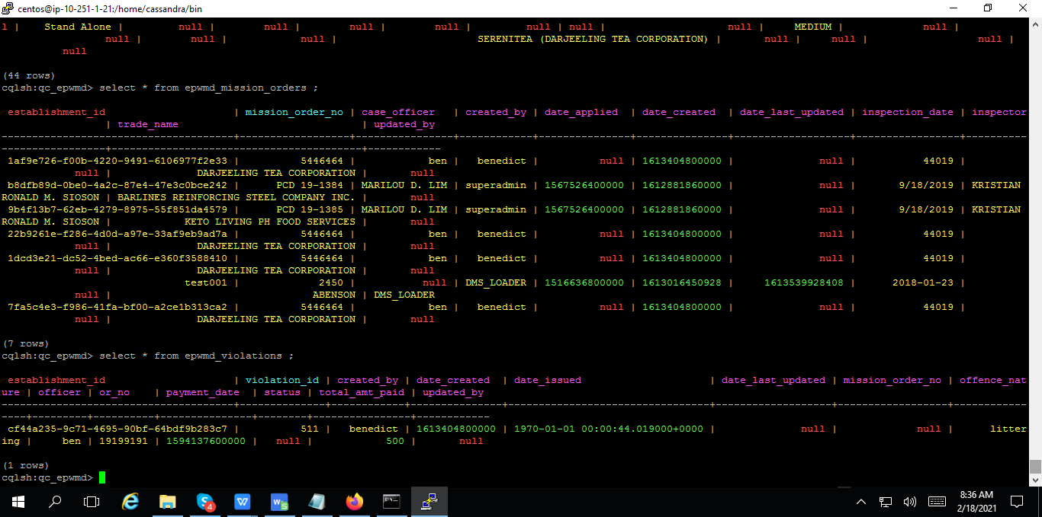

Cassandra table epwmd_solid_waste

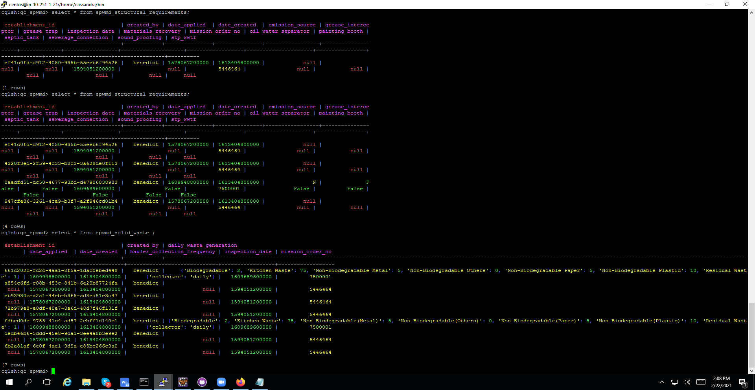

Cassandra table epwmd_hazardous_waste

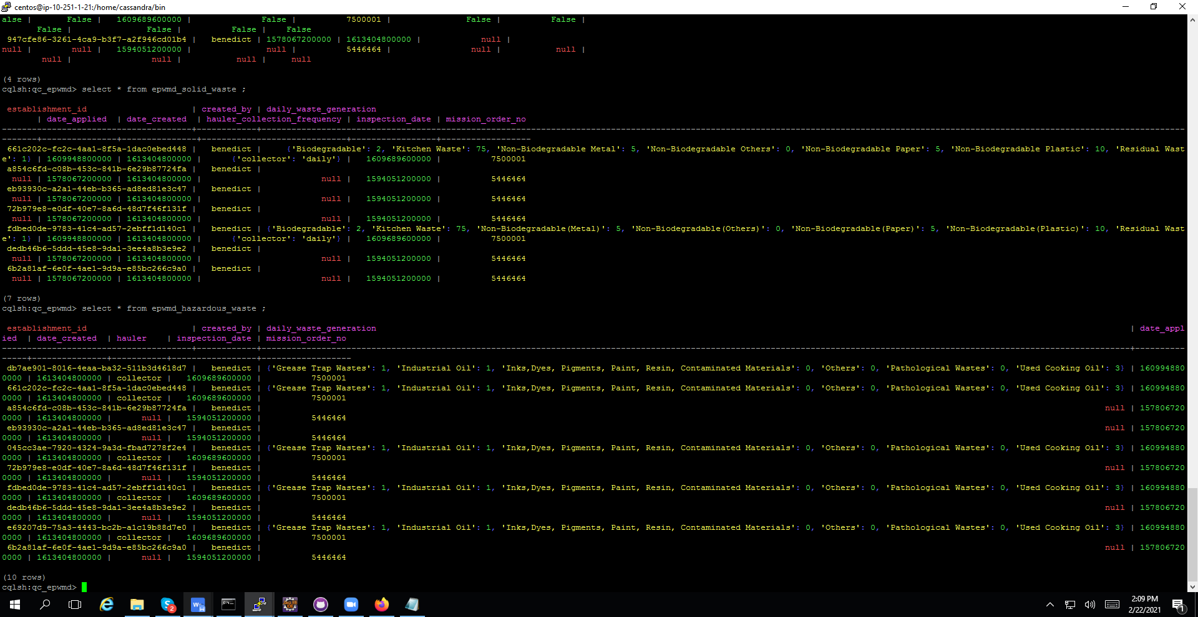

Cassandra table epwmd_structural_requirements

